BUILDING WORKS INSPECTION AND REPORT

on

Plot 4
5, Victoria Crescent,
Horsham,
West Sussex

Background Information
The inspection was carried out on 24 May 2019 at which time the weather was overcast, but dry.

Brief Description (Photo 1 – 3)
The subject property comprises a two-storey semi-detached dwelling with off street parking to side and small garden to rear. The building is believed to be of conventional construction.

Construction
• Roof – Pitched and gabled roof comprising preformed roof trusses overlaid with a microporous breater membrane and covered in slates.
Half round tiles are provided to the ridge.

• Walls – Cavity brick and block walls finished in face brick rising to tile hangings.

• Windows – Windows are double glazed, UPVC construction. Doors are composite construction or UPVC construction

• Ceilings – lined in plasterboard.

• Internal Walls - . Internal walls are part solid and part metal partition construction dressed in plasterboard.

• Floors – Upper floors are suspended timber joist. The ground floor is believed to be suspended concrete block and beam. Floors are finished in carpet or ceramic tiling.

Accommodation
• Ground floor: Hall, Sitting Room, Kitchen Diner, Utility, WC

• First floor: Master bedrooms with ensuite, 2 Further Bedrooms, Bathroom/wc, Landing

Instructions
In accordance with your recent instructions we carried out an inspection of this property to provide you with a Building Works Inspection report. External inspection was undertaken from ground level, surveyor’s 3 metre ladder. Not all parts of the chimneys or roof coverings were clearly visible. No practical demonstration of rainwater goods was possible.
The property was unoccupied and unfurnished. However, internal inspection was restricted by floor and wall coverings, fixtures and fittings, and the like. Elements of the structure normally concealed during construction such as floor voids and other voids and ducts were not exposed. No access was available behind or underneath bathroom or kitchen fittings.

Owing to the physical limitations upon the inspection as noted above, it is possible that other defects may be present but hidden from view. We have highlighted in the report areas that require further and more extensive examination.

Generally

It must be appreciated from the outset that number 3 (Plot 4) has only recently been constructed being completed in the last month or so. Therefore, as with any new house, faults have not yet had the time to materialize and show themselves. As the house settles down it is likely that some faults and defects will become apparent which were not evident at the time of this inspection.

You can expect, for instance, plaster cracking and shrinkage cracking to occur for up to 2 years, particularly above radiators, windows, doors, etc, which will require filling and decorating from time to time. This list will not be exhaustive, but we have tried to highlight the defects apparent and visible at this time.

This report should be construed as a comment upon the overall current condition of the property and is not an inventory of every single defect, some of which would not significantly affect the value of the property. This report is based upon the condition of the accessible parts of the property at the time of inspection and no liability can be accepted for any deterioration in its condition after this date.
NO LOCATION AND ITEM DESCRIPTION DEFECT (Photo No) REMEDY EXTERNAL OBSERVATIONS

1. STACK None.

2. ROOF Double pitched and gabled returning over rear addition and forming valley at abutment to adjacent. Roof slopes covered in natural slates. Angled tiles mechanically affixed to ridge. Valleys formed with fibre glass liner. Valley gutter lined fibre glass
none

3. RAINWATER GOODS PVC construction. Half round gutters letting to round downpipes directly to drains.
none

4. EXTERNAL WALLS External walls believed cavity brick and block construction. Elevations finished in face brick rising to tile hangings above first floor level. Extended reveals to first floor windows with lead aprons beneath. Edges of metal lintels and weep holes over ground floor openings. Ground floor window openings provided with stone sills. Subfloor vents 2 to front, 2 to flank, 5 to rear. Moulded GRP porch
Front –
Poor repair/mortar snot to RHS
sill (Photo 6)

Flank -
none

Rear -
none

Clean / repair

5. WINDOWS Double glazed UPVC. Trickle ventilators. 4 to front. 2 to flank. 4 to rear. Extended reveal and aprons beneath.
Front –
none

Flank
Missing end cap RHS of sill 1st floor window (photo 7). Sill Dirty

Protective tape to 1st floor window frame

Fit end cap. Clean and polish sill

Remove tape and polish

NO LOCATION AND ITEM DESCRIPTION DEFECT (Photo No) REMEDY
Rear
Protective tape to 1st floor window frame
Remove tape and polish

6. DOORS Front door – Composite with glazed light, level access sill.

French doors - double glazed, UPVC.
Face of door, frame and sill dirty (Photo 8, 9)

none
Clean and polish.
7. FASCIAS AND SOFFITS Barge boards, UPVC. none

NO LOCATION AND ITEM DESCRIPTION DEFECT (Photo No) REMEDY
8 ROOF SPACE Accessible via lockable plastic hatch to ceiling of landing.

Roof space provided with light. Un-boarded. No ladder.

Roof comprises pre-formed timber roof trusses with diagonal timber wind bracing. (Photo 10) over laid with microporous membrane

Gable walls and party walls formed in block work. Fibre glass insulation between and over joists.
No key to lock

Loft hatch poor trimmed out and plaster board ceiling susceptible to damage (Photo
11).

No ladder.

Microporous membrane poorly detailed adjacent valley

Builders debris including redundant / unused / damaged metal channel and fibre glass insulation wrapping lying in roof space (Photo 12, 13)

Insulation patchy between trusses (Photo 14)
Check key

Provide timber trimmers to front and rear edges of loft hatch

Provide Ladder

Cut away excessive membrane

Remove waste and tidy

Lift / relay insulation

NO LOCATION AND ITEM DESCRIPTION DEFECT (Photo No) REMEDY INTERNAL OBSERVATIONS

9 Master Bedroom inc En Suite & Dressing Room
Ceiling Plaster board. Emulsion Finish. Single pendant to Master Bedroom. 3 Down Lights & extract to En Suite. Single rose to Dressing Room.

Walls Plasterboard. Emulsion finish. En Suite walls part tiled to shower and wet areas behind WC and hand basin.

Floors Suspended timber. Carpet to Master Bedroom & Dressing Room, Tiling to En Suite.

Master Bedroom –
Minor ridge in ceiling extending from En Suite wall.

Dressing Room –
Minor gouge to ceiling to rear of rose, 300 mm from rear wall.(Photo 15)
Master Bedroom –
none

Dressing Room –
Minor open board joint / vertical fracture to internal wall with Master Bedroomdirectly above shelf (Photo 16)

En Suite
Tiling dirty / some silicon on tiles
Master Bedroom
Squeaky boards immediately adjacent En Suite Bathroom.

Dressing Room
none

Bathroom

Rub back, fill and redecorate.

Rub back, fill and redecorate.

Rub back, fill and redecorate.

Clean and polish. Re-secure

NO LOCATION AND ITEM DESCRIPTION DEFECT (Photo No) REMEDY
Variations in grout colour immediately adjacent the Shower (Photo17).]
Rake out & renew

Joinery Elements

Windows; UPVC casements to Master Bedroom and Bathroom. Window boards timber.

Doors; 3 panel faced doors in painted architraves and linings. Chrome door furniture.

Painted softwood skirting.

none

Master Bedroom; Hall Door Minor opening architrave mitre joints inside face and external face (Photo 18)

Door face dirty (photo 19)

Shrinkage fracturing at architrave with adjacent airing cupboard wall.

Ensuite Door
Minor opening architrave joints internal and external faces.(photo 20)

Dressing Room
Minor shrinkage fracturing, mitre internal and external faces.

Minor shrinkage fracturing at architrave, right hand side jamb within airing cupboard at abutment to door lining

No matters to report

Rub back, fill and redecorate

Clean splash marks from lower face.

Rub back, fill and redecorate

Rub back, fill and redecorate

Rub back, fill and redecorate

Rub back, fill and redecorate

NO LOCATION AND ITEM DESCRIPTION DEFECT (Photo No) REMEDY

Cupboard shelving Faced boards with chrome rails. none
Sanitary Fittings Glazed & tiled shower with mixer.
none

Radiators Steel radiator with independent control to Bedroom.
Chrome towel warmer to Bathroom.
none

Electrical Fittings 3 double sockets Master Bedroom. 4 light fittings.
Television socket and television outlet.
none

NO LOCATION AND ITEM DESCRIPTION DEFECT REMEDY

10 Front Left Bedroom

Plaster board. Emulsion Finish. Single pendant
Bedroom
none

Walls Plasterboard. Emulsion finish. none
Floor Suspended timber. Carpet none

Joinery Windows; UPVC casements to Bedroom. Window boards timber.

Doors; 3 panel faced doors in painted architraves and linings. Chrome door furniture.

Skirting – painted softwood timber.
none

Radiator Steel Radiator. Thermostatic radiator valve. No matters to report.

NO LOCATION AND ITEM DESCRIPTION DEFECT REMEDY

Electrical 3 double power sockets. Television outlet. Socket.
Light switch.
none

NO LOCATION AND ITEM DESCRIPTION DEFECT REMEDY

11 Front Right Bedroom

Ceiling Plaster board. Emulsion Finish. Single pendant to
Bedroom
none

Walls Plasterboard. Emulsion finish. none

Floor Suspended timber. Carpet none
Joinery Windows; UPVC casements to Bedroom. Window boards timber.

Doors; 3 panel faced doors in painted architraves and linings. Chrome door furniture.

Skirting – painted softwood timber.
Scratch to window board fill/sand and paint

Radiator Steel radiator. Thermostatic radiator valve. No matters to report.

Electrical 2 double sockets, television socket and outlet.
Light Switch.

No matters to report.

NO LOCATION AND ITEM DESCRIPTION DEFECT REMEDY
12 Bathroom (Photo 21)

Ceiling Plasterboard. Emulsion finish. 3 Down Lights.
Extract.

Central rose. Loft hatch, smoke detector.
No matters to report

Walls Plasterboard linings. Emulsion finish Boxing with soil pipe. Tiling to wet areas

Joinery Windows; UPVC casements to Bedroom. Window boards timber.

Doors; 3 panel faced doors in painted architraves and linings. Chrome door furniture.

Skirting – painted softwood timber.
Minor shrinkage fracturing at junction boxing to right hand wall. (Photo 22)

Tiling dirty

No matters to report

Face of door dirty. Shrinkage to architrave mitre joints
Rub back, fill, &
redecorate

Tiling requires cleaning and polishing

Clean paint smudges from face of bottom of door. Rub back & fill architrave joints

Sanitary Fittings Acrylic bath with glazed screen over. Mixer riser handset. China basin with central mixer. China WC.
WC lid/seat loose. Incorrectly fitted (Photo 23
Refit toilet seat

Radiator Steel radiator. Thermostatic radiator valve none
Electrical Fittings 1 socket. 3 light switches. Extract switch above door.
none

NO LOCATION AND ITEM DESCRIPTION DEFECT REMEDY
13 Landing & Stairs

Ceiling Plaster board. Emulsion Finish. none

Walls Plasterboard. Emulsion finish. none

Floor Suspended timber. Carpet none

Joinery Doors; 3 panel faced doors in painted architraves and linings. Chrome door furniture –

Skirting – painted softwood timber.
See bedrooms

Stairs - Timber construction, carpeted with hand rail. Timber balustrade
Shrinkage fracturing at stair trimmers to plaster work. (Photo 24). Various scuff marks to balustrades and landing newel post
Rub back, fill, &
redecorate

Radiator Steel radiator. Thermostatic radiator valve. none

Electrical Double sockets, Light Switches. none

NO LOCATION AND ITEM DESCRIPTION DEFECT REMEDY
14 KITCHEN DINING AREA (Photo 25 / 26)

Ceiling Painted plasterboard. 10 down lighters. Pendant rose. Smoke detector and carbon monoxide detector.
none.

Walls Painted plasterboard linings. none

Floors Suspended concrete / beam and block. Tiled finish. none
Joinery Windows; 3 UPVC casements. Window boards timber.
none

Door – Timber framed; part glazed. Painted architraves and linings.

Skirtings – painted softwood timber.

KITCHEN Wall and counter units with surface. Built in fridge freezer. Gas hob. Electric oven. Extract unit. Built in dishwasher.
Shrinkage fracturing to architrave at mitre joints and abut to adjacent plasterwork. (Photo 27, 28)

Open joint to rear of island unit.
none
Appliances not tested
Rub back, fill, &
redecorate

Rub back, fill, &
redecorate

Electrical Fittings 6 Double outlets. Switched outlets for appliances
Under counter lighting. Light Switches

NO LOCATION AND ITEM DESCRIPTION DEFECT REMEDY

15 Sitting Room

Ceiling Painted plaster board. Emulsion Finish. Single rose. none. .

Walls Painted plaster board. Emulsion Finish. none

Floor Concrete beam and block with carpet finish. none
Joinery Door – glazed timber, chrome furniture, painted linings and architrave.

French doors – double glazed, UPVC.
none

No matters to report. Unable to test.

Skirtings – painted softwood.
Open mitre joint to right hand flank wall 1 m back from corner.
Rub back, fill, &
redecorate

Radiator Steel radiator. Thermostatic radiator valve. none
Electrical Fittings 3 Double, Double television socket outlet. 2 light switches.
none

NO LOCATION AND ITEM DESCRIPTION DEFECT REMEDY
16 UTILITY AREA (Photo 29)

Ceiling Plaster board. Emulsion finish 2 down lights.
Extract.
None.

Walls Plaster board lining. Emulsion finish No matters to report.

Floor Suspended concrete / tiled finish. No matters to report.

Joinery Door – 3 panel. Painted linings and architraves.
Chrome furniture.

Counter units with stainless steel sink and mixer. Radiator Single radiator.
Shrinkage fracturing to architrave mitres and door linings to left hand side.

Expanded foam filler in cupboard (photo 30)
Rub back, fill, &
redecorate

Cut back and make good expanding foam below sink unit.

Electrical Fittings 2 double sockets plus spurred outlet light switch and thermostat.

NO LOCATION AND ITEM DESCRIPTION DEFECT REMEDY
17 CLOAKROOM

Ceiling Plaster board. Emulsion finish. Extract. Down lights No matters to report .

Walls Plaster board. Emulsion finish. Minor scuff / gouge marks to soil stack and right-hand wall adjacent and around access panel. (Photo 31)
Rub back, fill, &
redecorate

Floor Suspended concrete / tiled finish. None.

Sanitary Fittings China basin and WC. No matters to report

Joinery Door – 3 panel. Painted linings and architraves.
Chrome furniture.
No matters to report

Radiator Steel radiator No matters to report

NO LOCATION AND ITEM DESCRIPTION DEFECT REMEDY
18 HALLWAY & COAT CUPBOARD

Ceiling Plasterboard ceiling linings. Emulsion finish, 4 down lighters. Smoke detector.
No matters to report

Walls Plaster board linings. Emulsion finish. None.

Floor Tiled finishes. Concrete beam and block. None.

Joinery Windows – double glazed, casement, UPVC. Timber window boards

Doors.

Painted softwood skirtings
None.

See respective rooms

Radiator Single panel radiator. None.

NO LOCATION AND ITEM DESCRIPTION DEFECT REMEDY
19 Services
Services have not been tested. You should obtain copies of all commissioning and test certificates together with guarantees available
Electricity External meter
Distribution board in Hall Cupboard (Photo
32)

Gas External meter

Heating Wall mounted fan flue boiler (Kitchen – Boiler
Valiant Home System 15) serving radiators

Hot water Pressurized unvented in first floor airing cupboard
(Photo 33)

Drains Believed mains - PVC above ground Inspection chambers PVC.

Rain water goods – solicitors to verify if mains or to soakaway
Rims loose Secur

OTHER MATTERS

You are advised to ensure that you ascertain the following documentation and information from the Developers:-
• Is the property fully covered by an NHBC insurance policy or similar against major defects for at least the next ten years?
• Has the developer obtained full planning permission, Building Regulation approval and obtained a Completion
Certificate?
• Will the developer provide you with a full set of drawings and construction details for maintenance purposes?
• Has the roofer provided a guarantee? Again this ideally should be for at least 20 years, labour and materials?
• Is there full electrical certification available.
• Is there a GAS SAFE Certificate available.
• Confirm that the gas central heating boiler has been bench marked.
• Energy Performance Certificate for the property.
• Air Test Performance Certificate.
• Is there a homeowner’s manual on all appliances, this should include all working drawings, services, layout, full plans etc.
• Window and door guarantees and FENSA Certificate.
• Drainage test certificate and confirmation that this is correctly installed and laid to correct falls.

Finally you must appreciate that once you start to live in the property then further defects are likely to become apparent. If you can,
you should ask to retain a small percentage of the purchase price (2.5%) for a defects liability period (6 months or more), which would encourage the developer to come back and complete any outstanding snagging items that become apparent.

24th May 2019
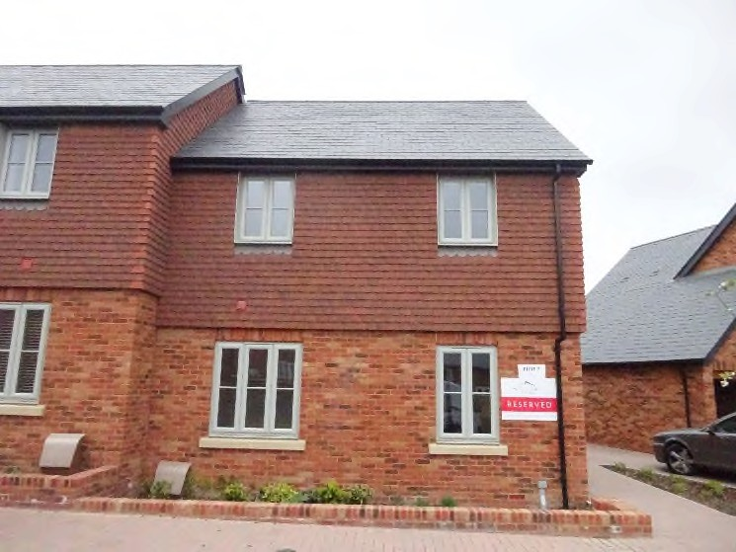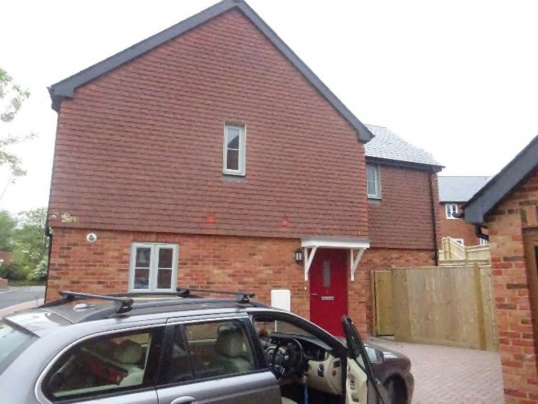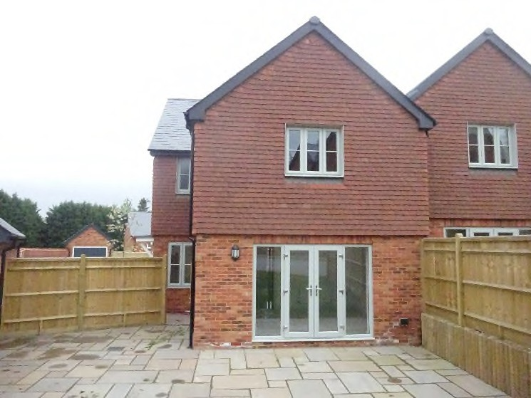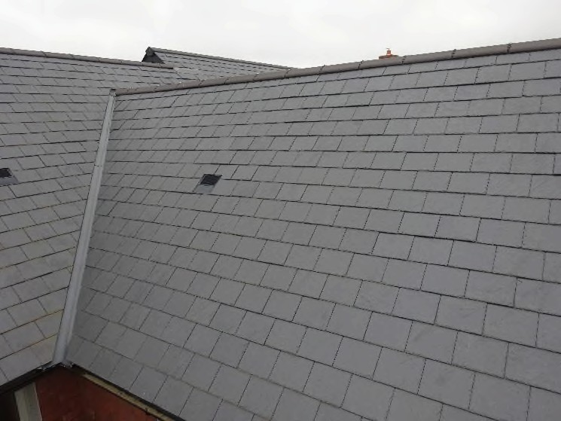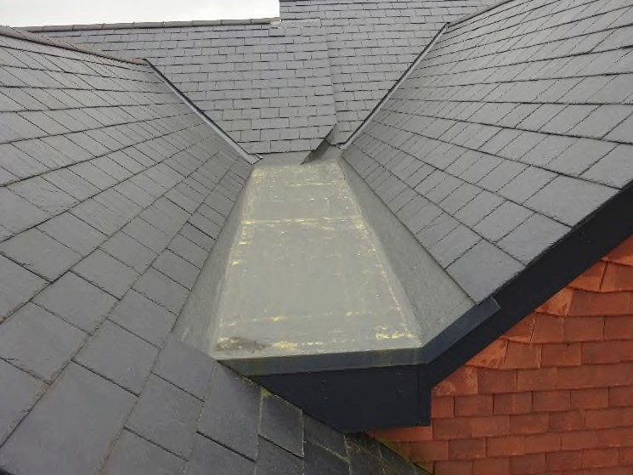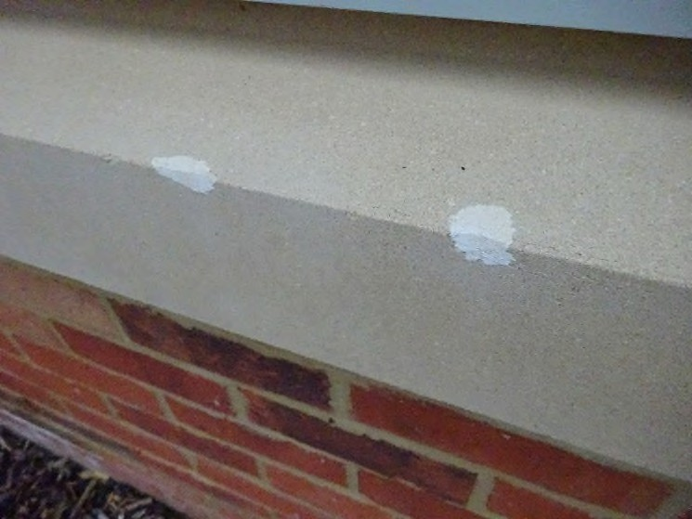

1 (Front) 2 (Side)

3 (Rear) 4

5 6
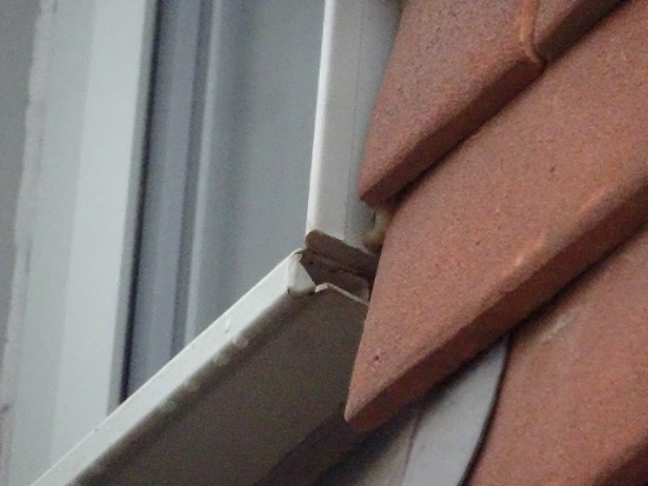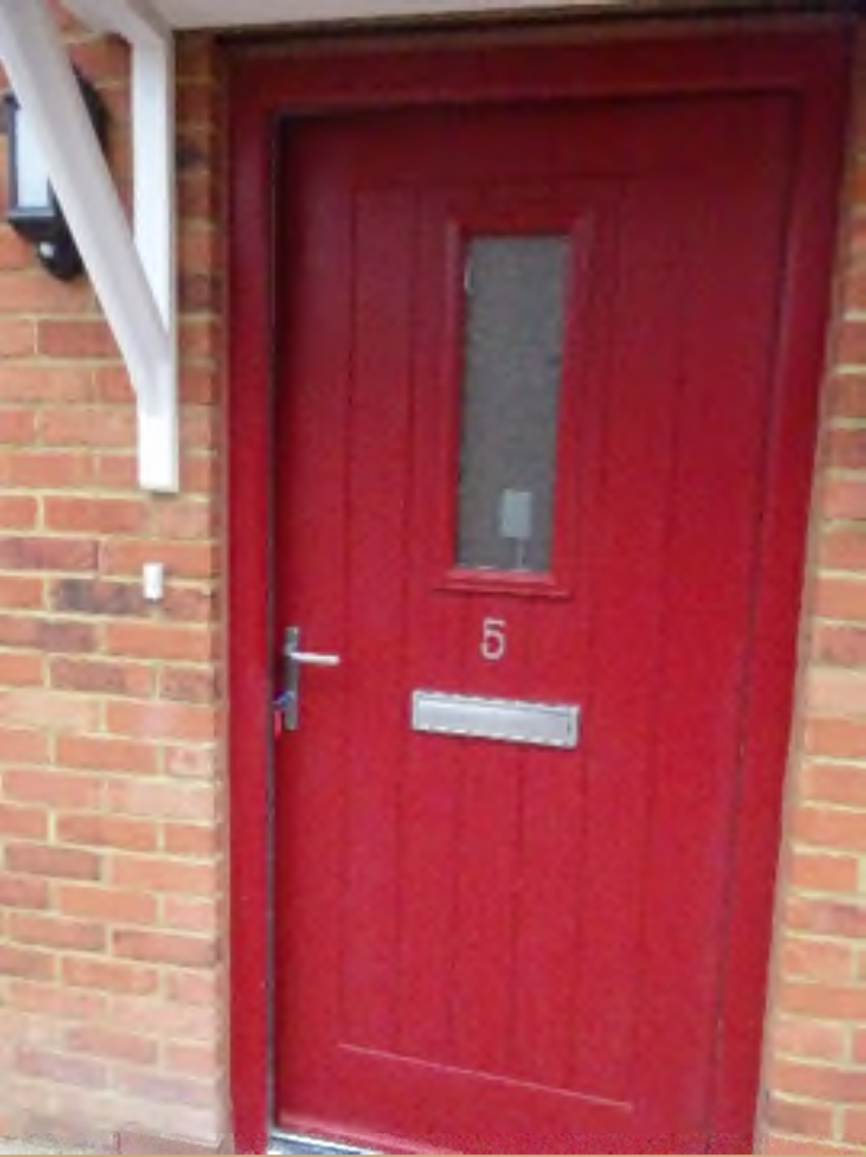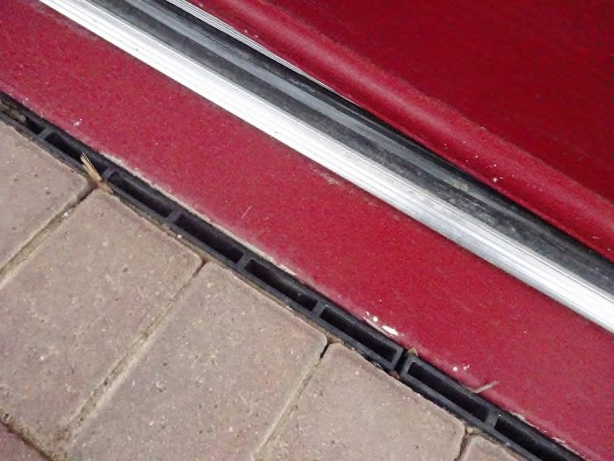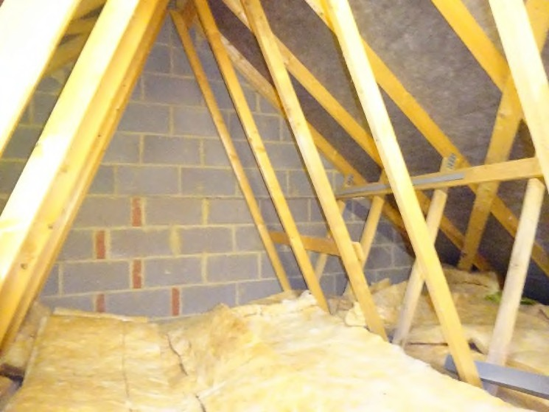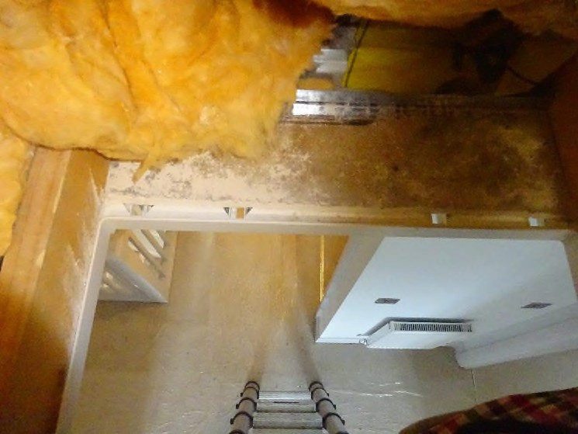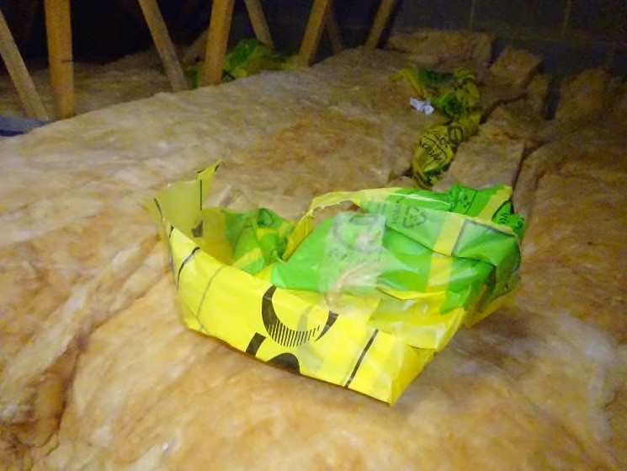

7 8

9 10

11 12
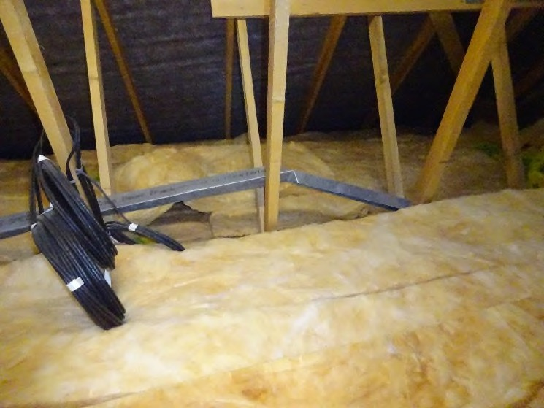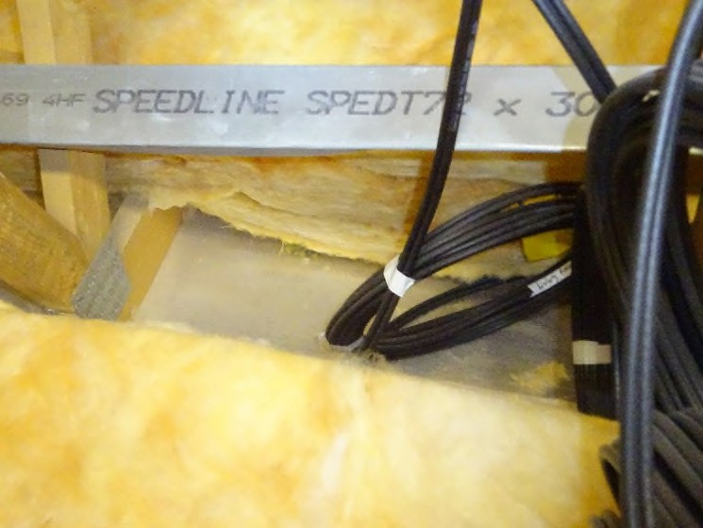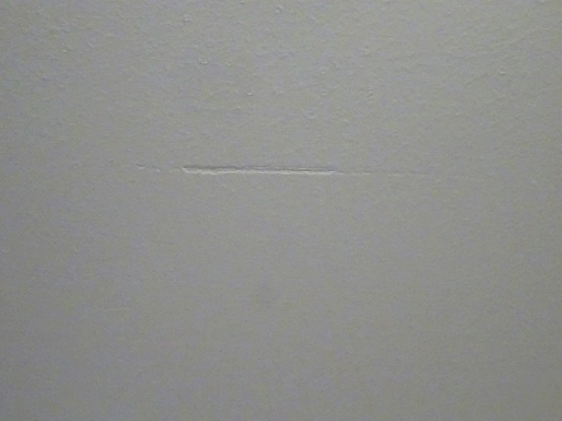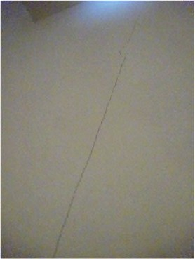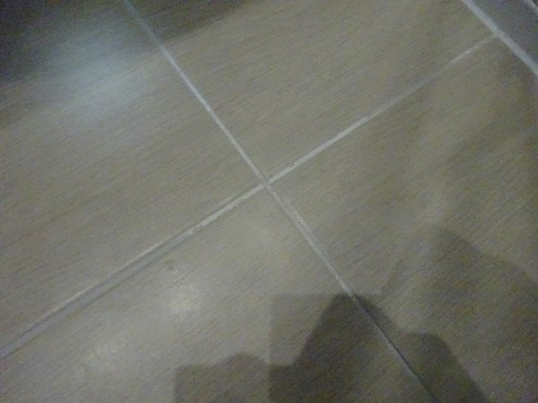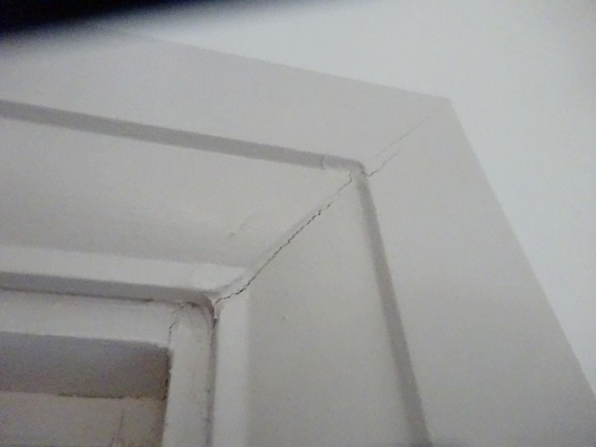

13 14

15 16

17 18
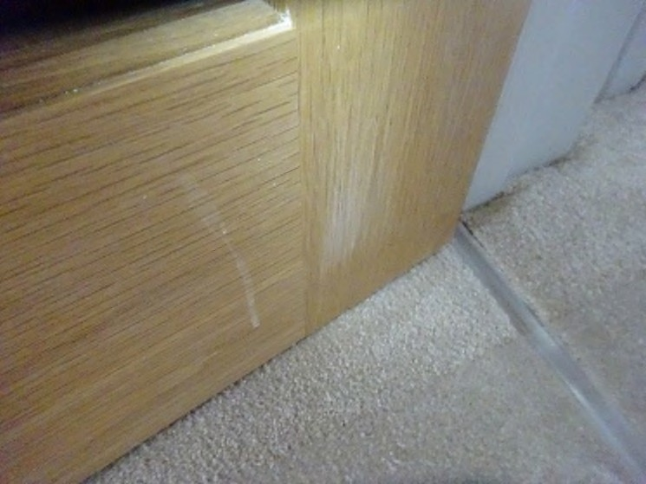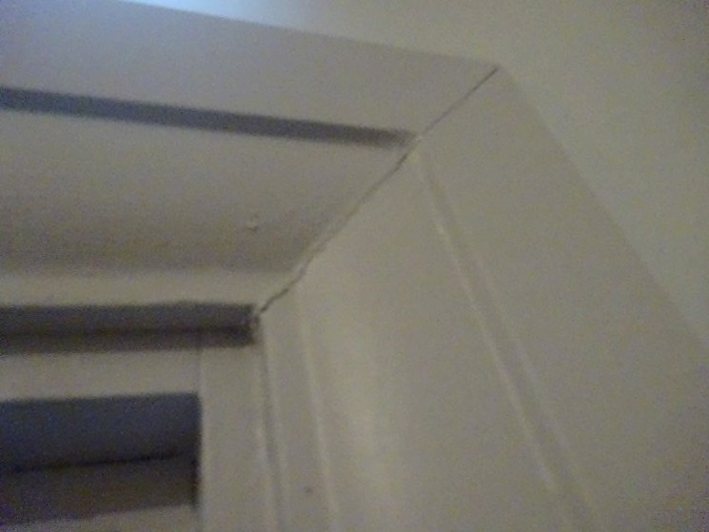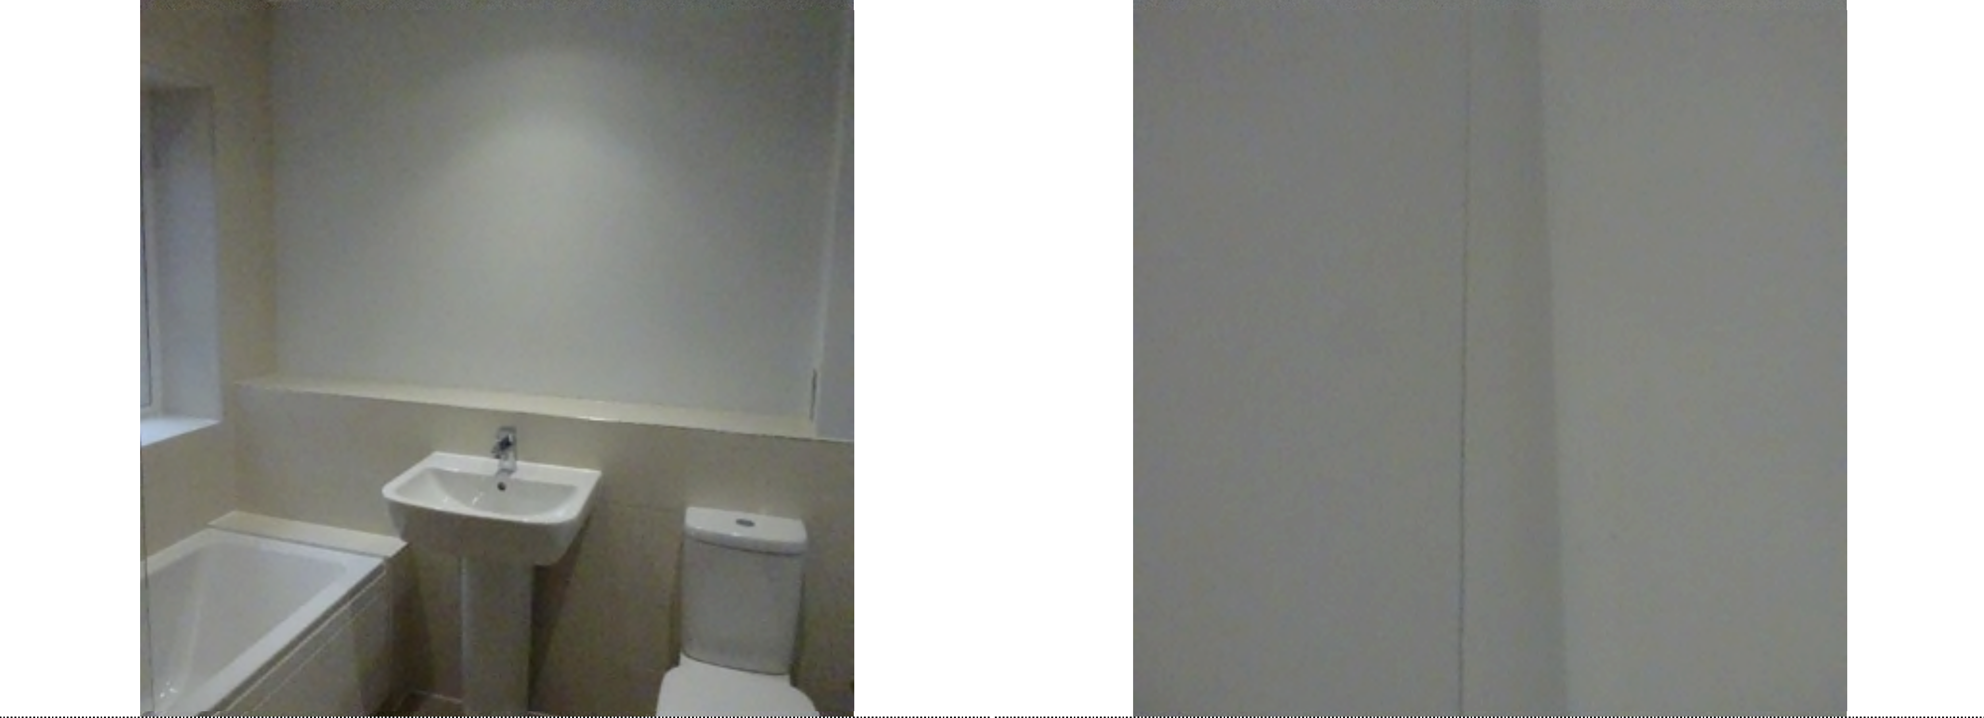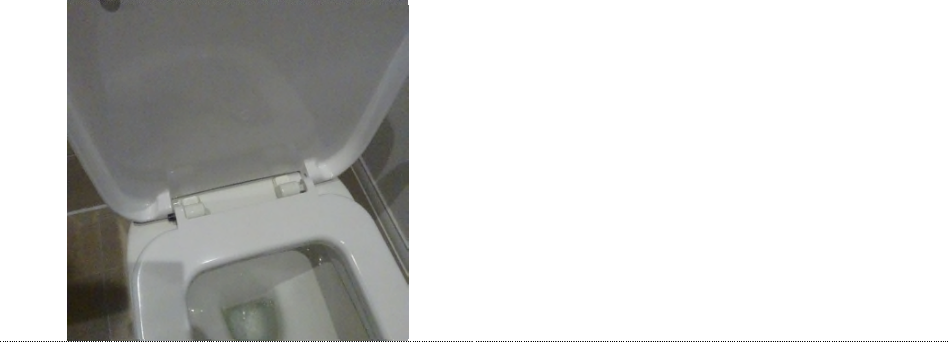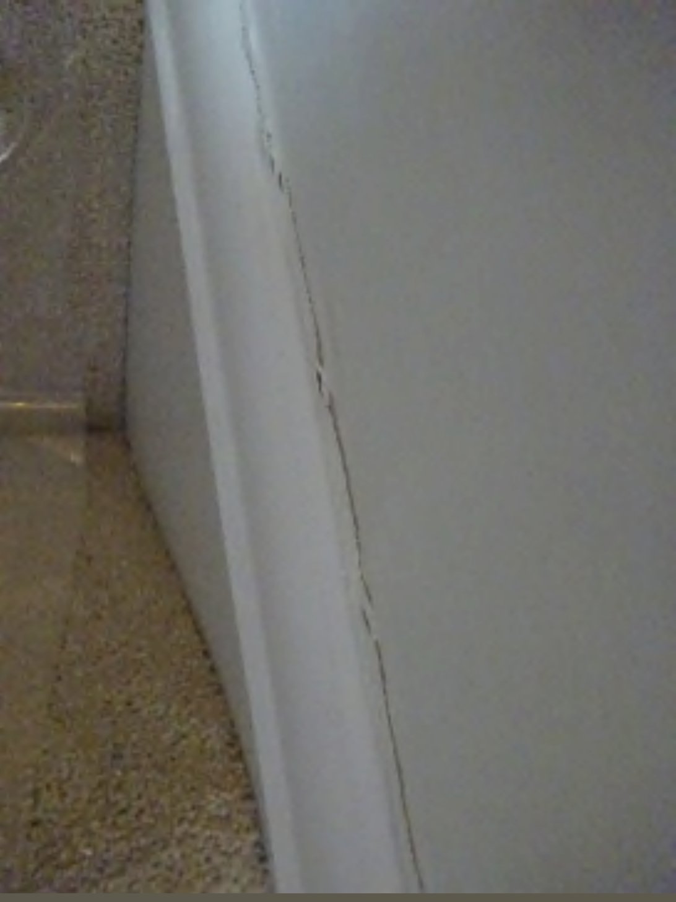

19 20

21 22

23 24

